|  |  |
| --- | --- |
| cetlogo ***CHEMICAL ENGINEERING TRANSACTIONS***  ***VOL. xxx, 2025*** | A publication of  aidiclogo_grande |
| The Italian Association  of Chemical Engineering  Online at www.cetjournal.it |
| Guest Editors: Fabrizio Bezzo, Flavio Manenti, Gabriele Pannocchia, Almerinda di Benedetto  Copyright © 2025, AIDIC Servizi S.r.l. **ISBN** 979-12-81206-17-5; **ISSN** 2283-9216 | |

Computer-aided Simulation of a Cascade Biorefinery: Case Study of the Colombian Amazon’s Hass Avocado Waste

Anibal Alviz-Meza, Stefany A. Valdez-Valdes, Ángel Darío González-Delgado\*

Chemical Engineering Department, Nanomaterials and Computer-Aided Process Engineering Research Group (NIPAC), Universidad de Cartagena, Cartagena 130014, Bolívar, Colombia.

[\*agonzalezd1@unicartagena.edu.co](mailto:*agonzalezd1@unicartagena.edu.co)

Colombia has become a key producer of avocados, benefiting from its rich biodiversity and agricultural potential. However, the industry primarily focuses on the fruit’s pulp, while the wastes are often discarded. This study proposes a cascade biorefinery to transform these underutilized byproducts into valuable materials. The process was simulated using Aspen Plus software. The first stage in the cascade biorefinery involves waste pretreatment—washing, size reduction, wet extraction, filtration, decantation and drying—resulting in a 50% starch recovery from the initial input. The second and third stages focus on bioplastic film production through hydrolysis, fermentation, purification, polymerization, gelatinization, and drying, achieving a 36% conversion into biodegradable films. With a total processing capacity of 27.4 kg/h of avocado wastes, the biorefinery repurposes agricultural waste into high value bioproducts. The simulation provides key insights into material balances, stream compositions, and operational conditions, demonstrating the technical feasibility of this approach. By valorizing avocado waste, this study presents a sustainable strategy to enhance the economic potential of avocado cultivation in Colombia.

* 1. Introduction

The world is slowly moving toward economic development tailored to sustainable processes. Global warming, inequality, and hunger are major concerns caused by the depletion of natural resources, boosted by centuries of extractive economies. In this context, the bio-economy emerges as an environmental solution to provide energy, chemicals, and biomaterials to society (Lara-Flores et al., 2018).

In Colombia, Hass avocado cultivation is representative in departments such as Antioquia, Valle del Cauca, Quindío, Tolima, and Bolívar (Ceballos et al., 2013). The Amazon avocado production represents 10% of the local economy, which has allowed them to attract important European trading partners, such as the Netherlands (Sanchez et al., 2021). However, the actual Amazon avocado production chain is limited to the commercialization of fresh fruit, reducing its competitiveness and endorsing health and environmental challenges to its communities due to the improper handling of its agroindustrial residues (Ong et al., 2021). These arguments reveal promising research opportunities to enhance the sustainable use of avocado residues in the Amazon region. Avocado is a valuable commodity for its pulp and oil, but its seed and peel are attractive to valorize wastes and increase the sector's competitiveness and investors’ appeal. Avocado seeds are rich in nutrients and bioactive compounds that can lead to multiple value-added products (Yepes et al., 2021). Therefore, it is possible to apply the concept of cascade biorefinery to the Hass avocado production chain. This involves a sequential extraction of the different components from Hass avocado wastes, such as oils, antioxidants, fiber, and proteins, for their transformation into value-added products.

The introduction of biorefineries for valorizing agro-industrial wastes —circular economy— has become part of this approach since biomass stocks require multiproduct processes to be more attractive to investors. The peels and seeds are sources of antioxidant and anti-inflammatory compounds, useful in nutraceutical and pharmaceutical products (Rodríguez-Martínez et al., 2021). In the energy sector, organic avocado waste can be anaerobically fermented to produce bio-gas while extracted oils can be transformed into biodiesel through transesterification (Ginting et al., 2020). Similar approaches in cascading biorefineries have demonstrated their potential in the conversion of agricultural residues into biofuels and biomaterials, as seen in studies utilizing coffee grounds for biodiesel production (Acosta Suasnabar et al., 2023) and the extraction of fermentable sugars from herbaceous crops for bio-based applications (Lopez Fetzer et al., 2024). These strategies highlight the feasibility of multi-product valorizations, reinforcing the importance of applying biorefinery principles to avocado residues (García-Maza et al., 2024).

Moreover, integrated avocado utilization in bio-economy models poses feasibility challenges that can be addressed by computer-aided process simulation in biorefineries (Solarte-Toro et al., 2021). For instance, software such as Aspen Plus can be used in this context to explore diverse process scenarios to obtain the most sustainable and profitable conditions (Sousa et al., 2024). The particular use in handling avocado and its residues remains limited. However, important works such as those of Herrera-Rodríguez et al. (2022) show how the multi-product utilization of avocado generates the best economic, environmental, and energy results. In light of the above, the objective of this research work was to design and model a cascading biorefinery that efficiently and profitably extracts and processes the components of Hass avocado wastes for the production of starch and biofilms, thereby minimizing waste and promoting sustainability in the avocado industry.

* 1. Materials and methods

Below we briefly describe our simulation approach in Aspen Plus to enable a cascade biorefinery using the Hass avocado waste from the Colombian Amazon region.

* + 1. Processing capacity

The upper region in the Colombian Amazon was taken as a case study to obtain data on Hass avocado production. The avocado Hass’ waste production capacity in Putumayo was estimated at 1500 t/y based on data reported in 2022 from the Agricultural Ministry of Agriculture and Rural Development of Colombia in its Agronet web portal. 20% was assumed to be the waste weight percentage relative to the fruit (Charles et al., 2022). The processing capacity of the biorefinery was established at 50% of the theoretical maximum waste production —around 264.54 t/y. The material balance also required the composition of the Hass avocado seed, taken from the work of Tesfayev et al. (2018), pressure and temperature conditions, mass flows, and each stream’s composition.

* + 1. Simulation approach

The cascade biorefinery process shown in Figure 1 was divided into two major sections: the first section, from the entry of the waste to the starch extraction process; and the second, where the waste and liquid filtrate are processed to generate polylactic acid and biofilms. Section 1 includes the stages of washing, size reduction, wet extraction, filtration, and decantation. Section 2 considers the stages of hydrolysis, fermentation, neutralization, filtration, decantation, washing, and others.

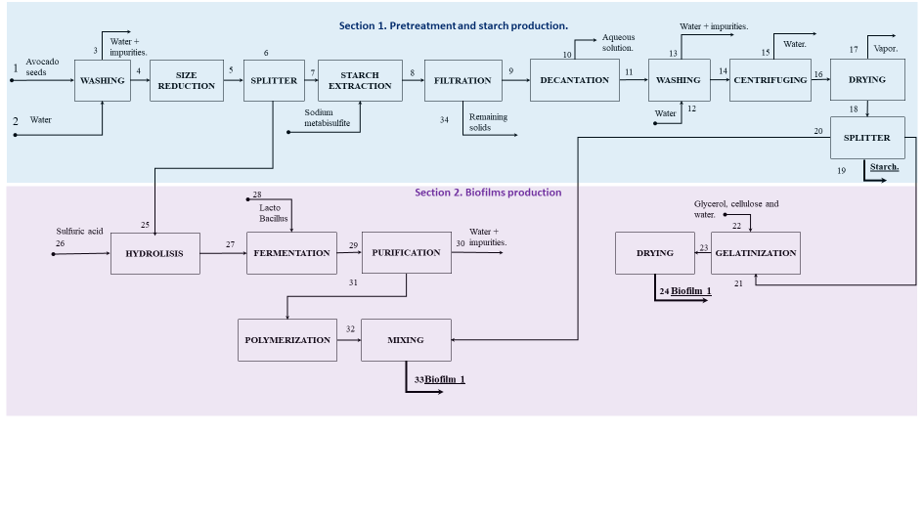

Figure 1: Simplified diagram of the Hass avocado wastes process to produce biofilms and starch.

In broad outline, Figure 1 shows the proposed cascade biorefinery process for valorising Hass avocado wastes. The extraction of carbohydrates from the waste leads to the production of starch, which is partially used for its transformation into Biofilm 1 (through gelatinization with glycerol) and Biofilm 2 (after conversion into lactic acid, fermentation, and polymerization to PLA). This process makes the most of the biomass, promoting the development of sustainable bioproducts.

On the other hand, to simulate the biorefinery, Aspen Plus with the NRTL-RK and the Redlich-Kwong thermodynamic models were chosen to model the liquid and vapor phases, respectively. The next step was to model the three major sections as well as select and/or adjust the pressure and temperature conditions. With the above-mentioned production capacity and the proximal composition of Hass avocado determined by Tesfaye et al. (2018), the assumptions shown in Table 1 were made about each category. Moisture was taken as water, ash as calcium oxide, crude protein as serine, crude lipid as oleic acid, crude fibre, and carbohydrate as glucose.

This simulation was based on experimental data reported by various authors regarding temperature, pressure, composition, and yield conditions. Considering the most optimistic data in the consulted papers, this work delivers the highest possible yield for biofilms and starch.

Table 1: Avocado waste on a dry basis composition approach.

|  |  |  |  |  |  |  |
| --- | --- | --- | --- | --- | --- | --- |
|  | Moisture | Ash | Crude protein | Crude lipid | Crude fiber | Carbohydrate |
| Avocado waste |  |  |  |  |  |  |

* 1. Results and discussion
     1. Modeling and computer-aided process simulation (cape) of the starch production from hass avocado waste

Figure 2 shows the starch production section simulation in Aspen Plus. The process is initiated by washing 27.4kg/h of Hass avocado wastes at room temperature (25°C) and atmospheric pressure (1bar), using a 3:1 waste/water ratio. These wastes are dried (see stream 8 in Figure 2) in a convective dryer with hot air at 50°C. The dry wastes are cut into big pieces of 3cm before going through a stream separation process, where 40% of the wastes are led to biofilms production. The remaining 60% is derived to stream 11, where the starch is extracted, by being exposed to a sodium metabisulfite solution for 24h (stream 12). This mixture undergoes blending (stream 14) at room temperature, followed by a filtration where the liquid phase —containing the starch— enters the decantation process. Then, the starch is washed (stream 42) while remaining at room temperature. Lastly, the starch is dried at 60°C and separated into three parts: streams 50 and 51 go to biofilms production while stream 49 is conditionate as one of the biorefinery products. 1.92kg/h of starch is produced in this biorefinery.

*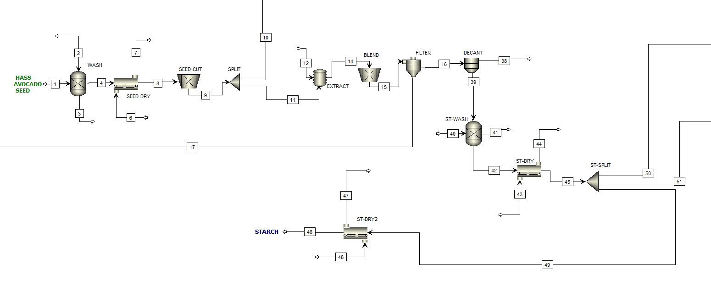*

*Figure 2: Simulation of the starch production process from the waste of Hass avocado in the ASPEN plus® software*

The obtained starch composition in the simulated process includes 7.2% crude protein, 9% crude fat, 2.78% ash, and 74.3% carbohydrates. These values are similar to those reported by Mahawan et al. (2015), who studied avocado seed flour, finding 7.75% protein, 0.71% fat, 2.83% ash, and 74.65% carbohydrates. These differences could be attributed to factors such as process conditions —extraction time and temperature— and employed analytical techniques. Similar results in carbohydrate content confirm the efficiency of the approach used to recover starch as the main component. This compositional evaluation is key to validating the technical efficiency of the process and its contribution to the sustainability of the integral use of avocado wastes.

* + 1. Computer-aided process simulation and modeling of the production of the biofilm from Hass avocado waste

*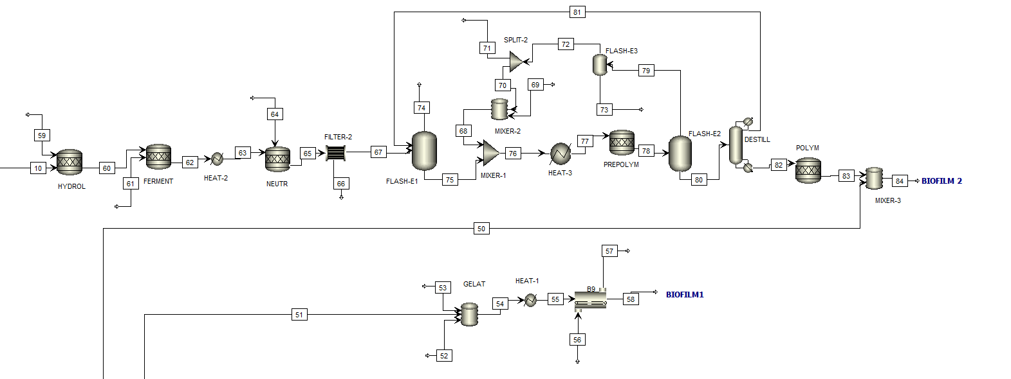*After the starch extraction and separation for biofilm 1 production (stream 51), it is gelatinized at 65°C with water and glycerol (streams 52 and 53). This mixture is dried at 100°C to evaporate the excess water to produce 3.76 kg/h of biofilm (stream 58). For the biofilm 2 elaboration, after the stream separation containing part of the cut waste (stream 10 in Figure 2 and Figure 3), a hydrolysis process is conducted at 121°C using sulfuric acid. This converts complex carbohydrates of the waste into reducing sugars for lactic acid production (Jayasekara et al., 2022). After stream 60, the fermentation stage is performed, where Lactobacillus and Calcium Hydroxide are added to produce lactic acid and control the medium pH, respectively.

*Figure 3:* Simulation of the biofilms production process from the waste of Hass avocado in ASPEN plus® software

Stream 62, which contains lactic acid and impurities, is heated at 70°C, neutralized with sulfuric acid, and filtrated to remove the unreacted waste residues as much as the gypsum formed. A flash evaporation at 100°C and 0.5 bar is then carried out to concentrate the lactic acid. Then, using a nitrogen-inert reactor, the prepolymers of polylactic acid (M-Lactide and L-Lactide) are obtained at 240°C and atmospheric pressure (Heo et al., 2019). In the “FLASH E-2” equipment, the lactides are separated from nitrogen (stream 79) to be recovered, purged, and reintroduced into the process (stream 68 to stream 73). Lactides from stream 80 enter distillation to recover the lactic acid not converted (stream 81). The concentrated lactides get into the polymerization reactor to generate polylactic acid at 200°C and 2bar (Jayasekara et al., 2022). Finally, the polylactic acid is mixed with starch to produce 3.44 kg/h of biofilm 2.

This work modeled the production of two types of biofilms: one composed of Hass avocado waste starch and glycerol, and the other of starch combined with polylactic acid (PLA). The starch and glycerol biofilm showed similarities with the findings of Jimenez et al. (2021), who discovered that glycerol contributes to reducing the rigidity and brittleness of the films. This behavior, attributed to the hydrophilic character of glycerol, decreases tensile strength and improves water vapor permeability, making them suitable for applications as coatings in low-moisture foods. Unlike Jimenez et al. (2021), this study incorporates PLA obtained from the hydrolysis, fermentation, and polymerization of lactic acid from the avocado waste. The combination of PLA and starch significantly enhances the mechanical properties of the biofilms, offering greater strength and flexibility while maintaining their biodegradability. This approach takes full advantage of the waste's components, expanding potential applications to sectors that demand more robust and functional materials. This advance also reaffirms the added value of agro-industrial waste under a circular and sustainable economy scheme.

Table 2: Summarized results for the mass rate of products obtained through the Aspen Plus approach.

|  |  |  |  |
| --- | --- | --- | --- |
|  | Starch | Biofilm 1 | Biofilm 2 |
| Mass rate [kg/h] | $$1.92$$ | $$3.76$$ | $$3.44$$ |

Table 2 shows the mass rate output of products of the biorefinery. In addition, a mass yield of 78.34% can be achieved in the proposed refinery from Hass avocado wastes. These results reinforce the feasibility of the process to produce sustainable and effective bio-products from the cascade biorefinery approach. In the future, we recommend exploring the combined effect of other bioactive compounds in the waste for further optimization.

* 1. Conclusions

The computer-aided simulation of a cascading biorefinery based on Hass avocado wastes from the Amazon Colombian region demonstrated a promising potential for sustainable waste valorization. The simulation was carried out in Aspen Plus, using the NRTL —liquid phase— and Redlich-Kwong —vapor phase— thermodynamic models. As a result, 1.92 kg/h of starch, 3.76 kg/h of starch-glycerol-based biofilm, and 3.44 kg/h of starch-PLA biofilm were obtained, achieving an overall yield of 78.34% —highlighting the feasibility of the process at an industrial scale. These results show the potential of using agricultural waste on an industrial scale. Finally, the optimization of stream recirculation and the integration of renewable energies are recommended to strengthen sustainability.

Acknowledgments

The authors thank the Universidad de Cartagena and the Colombian Ministry of Science, Technology and Innovation MINCIENCIAS, who funded this work through the project “Evaluation of the sustainability of a cascade biorefinery topology for the use of Hass avocado seeds cultivated in the Amazon region”, Code SIGP 100307 and contract 442-2023.

References

Acosta Suasnabar E.H., Camarena Taxa L.P., Ordoñez Gálvez J.J., Benites-Alfaro E., 2023, Oil Extracted from Coffee Grounds to Obtain Biodiesel as Renewable Energy, CET Journal-Chemical Engineering Transactions, 105.

Ceballos A., Montoya S., 2013, Evaluación química de la fibra en semilla, pulpa y cáscara de tres variedades de aguacate, Biotecnología en el Sector Agropecuario y Agroindustrial, 11(1), 103-112.

Charles A.C., Dadmohammadi Y., Abbaspourrad A., 2022, Food and cosmetic applications of the avocado seed: a review, Food & Function, 13(13), 6894-6901.

García-Maza S., Herrera-Rodríguez T.C., González-Delgado Á.D., 2024, Process Simulation and Technical Evaluation Using Water-Energy-Product (WEP) Analysis of an Extractive-Based Biorefinery of Creole-Antillean Avocado Produced in the Montes De María, Sustainability, 16(21), 9575.

Ginting M.H.S., Misran E., Maulina S., 2020, Potential of durian, avocado and jackfruit seed as raw material of bioethanol: A review, IOP Conference Series: Materials Science and Engineering, 801(1), 012045.

Heo S., Park H.W., Lee J.H., Chang Y.K., 2019, Design and evaluation of sustainable lactide production process with an one-step gas phase synthesis route, ACS Sustainable Chemistry & Engineering, 7(6), 6178-6184.

Herrera-Rodríguez T., Parejo-Palacio V., González-Delgado Á., 2022, Computer-aided simulation of avocado oil production in North Colombia, Chemical Engineering Transactions, 92, 415-420.

Jayasekara T., Wickrama Surendra Y., Rathnayake M., 2022, Polylactic acid pellets production from corn and sugarcane molasses: Process simulation for scaled-up processing and comparative life cycle analysis, Journal of Polymers and the Environment, 30(11), 4590-4604.

Jimenez R., Sandoval-Flores G., Alvarado-Reyna S., Aleman-Castillo S.E., Santiago-Adame R., Velazquez G., 2021, Extraction of starch from Hass avocado seeds for the preparation of biofilms, Food Science and Technology, 42, e56820.

Lara-Flores A.A., Araújo R.G., Rodríguez-Jasso R.M., Aguedo M., Aguilar C.N., Trajano H.L., Ruiz H.A., 2018, Bioeconomy and biorefinery: valorization of hemicellulose from lignocellulosic biomass and potential use of avocado residues as a promising resource of bioproducts, Waste to Wealth, 141-170.

Lopez Fetzer D.E., Andrade T.A., Ambye-Jensen M., 2024, Xylose, Glucose and Fructose Extraction from Different Herbaceous Crops in a Green Biorefinery Demonstration Platform: a Comparative Study, CET Journal-Chemical Engineering Transactions, 109.

Mahawan M.A., Tenorio M.F.N., Gomez J.A., Bronce R.A., 2015, Characterization of flour from avocado seed kernel, Asia Pacific Journal of Multidisciplinary Research, 3(4), 34-40.

Ong E.S., Low J., Tan J.C.W., Foo S.Y., Leo C.H., 2022, Valorization of avocado seeds with antioxidant capacity using pressurized hot water extraction, Scientific Reports, 12(1), 13036.

Rodríguez-Martínez B., Ferreira-Santos P., Gullón B., Teixeira J.A., Botelho C.M., Yáñez R., 2021, Exploiting the potential of bioactive molecules extracted by ultrasounds from avocado peels—food and nutraceutical applications, Antioxidants, 10(9), 1475.

Solarte-Toro J.C., Ortiz-Sanchez M., Restrepo-Serna D.L., Piñeres P.P., Cordero A.P., Alzate C.A.C., 2021, Influence of products portfolio and process contextualization on the economic performance of small-and large-scale avocado biorefineries, Bioresource Technology, 342, 126060.

Sousa D., Rodrigues D., Castro P.M., Matos H.A., 2023, Equation-Oriented Modeling and Optimization of a Biorefinery Based on Avocado Waste, Processes, 12(1), 91.

Tesfaye T., Gibril M., Sithole B., Ramjugernath D., Chavan R., Chunilall V., Gounden N., 2018, Valorisation of avocado seeds: extraction and characterisation of starch for textile applications, Clean Technologies and Environmental Policy, 20, 2135-2154.

Yepes-Betancur D.P., Márquez-Cardozo C.J., Cadena-Chamorro E.M., Martinez-Saldarriaga J., Torres-León C., Ascacio-Valdes A., Aguilar C.N., 2021, Solid-state fermentation–assisted extraction of bioactive compounds from Hass avocado seeds, Food and Bioproducts Processing, 126, 155-163.